**Lab no 5**

**Priority Scheduling**

***Objectives:***

* What is priority scheduling?
* Implementation of preemptive priority scheduling on different arrival time.
* Implementation of non-preemptive priority scheduling.

**Priority Scheduling:**

**Priority Scheduling** is a method of scheduling processes that is based on priority. In this algorithm, the scheduler selects the tasks to work as per the priority.

The processes with higher priority should be carried out first, whereas jobs with equal priorities are carried out on a round-robin or FCFS basis. Priority depends upon memory requirements, time requirements, etc.

**Type of Priority Scheduling:**

Priority scheduling divided into two main types:

**Preemptive Scheduling**

**In Preemptive Scheduling, the tasks are mostly assigned with their priorities. Sometimes it is important to run a task with a higher priority before another lower priority task, even if the lower priority task is still running. The lower priority task holds for some time and resumes when the higher priority task finishes its execution**

**Non-Preemptive Scheduling**

**In this type of scheduling method, the CPU has been allocated to a specific process. The process that keeps the CPU busy, will release the CPU either by switching context or terminating. It is the only method that can be used for various hardware platforms. That’s because it doesn’t need special hardware (for example, a timer) like preemptive scheduling.**

**Characteristics of Priority Scheduling**

* A CPU algorithm that schedules processes based on priority.
* It used in Operating systems for performing batch processes.
* If two jobs having the same priority are READY, it works on a FIRST COME, FIRST SERVED basis.
* In priority scheduling, a number is assigned to each process that indicates its priority level.
* Lower the number, higher is the priority.
* In this type of scheduling algorithm, if a newer process arrives, that is having a higher priority than the currently running process, and then the currently running process is preempted.

**Example of Priority Scheduling**

**Consider following five processes P1 to P5. Each process has its unique priority, burst time, and arrival time.**

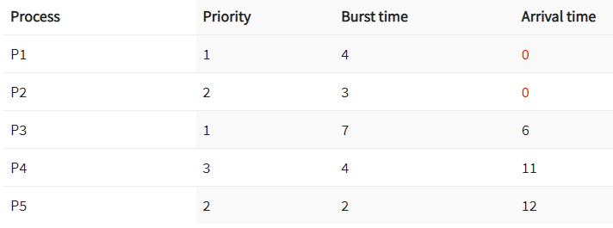

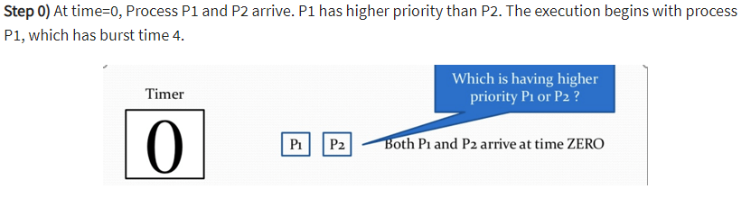

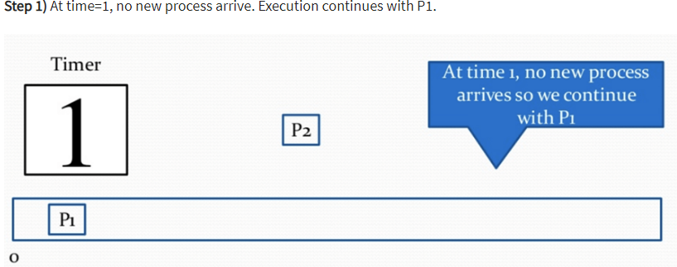

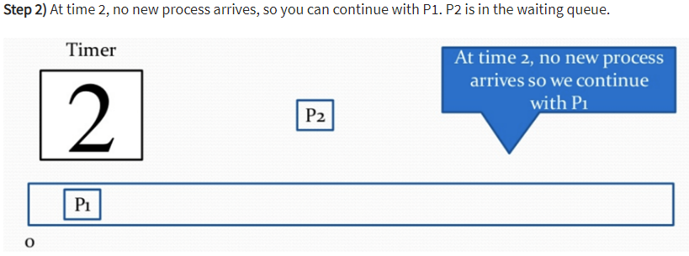

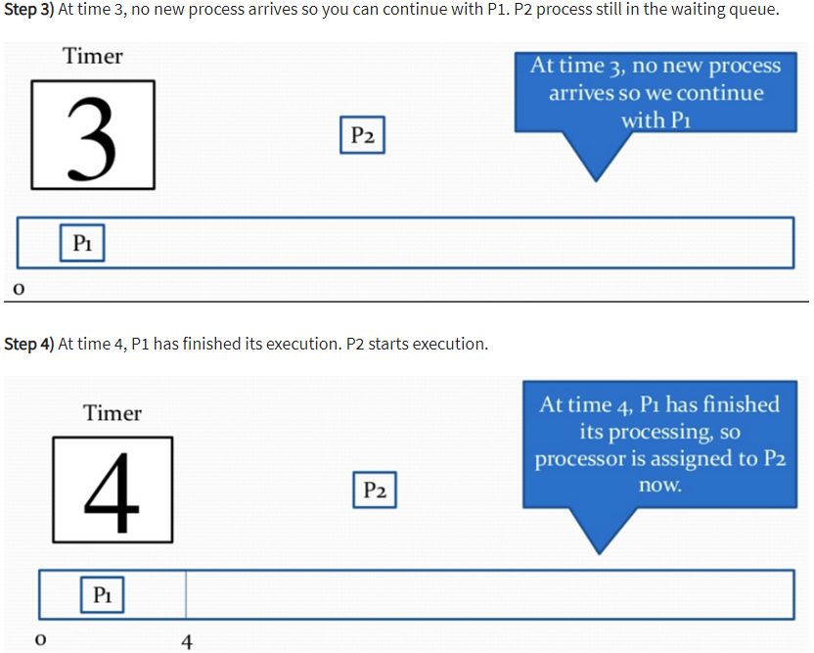

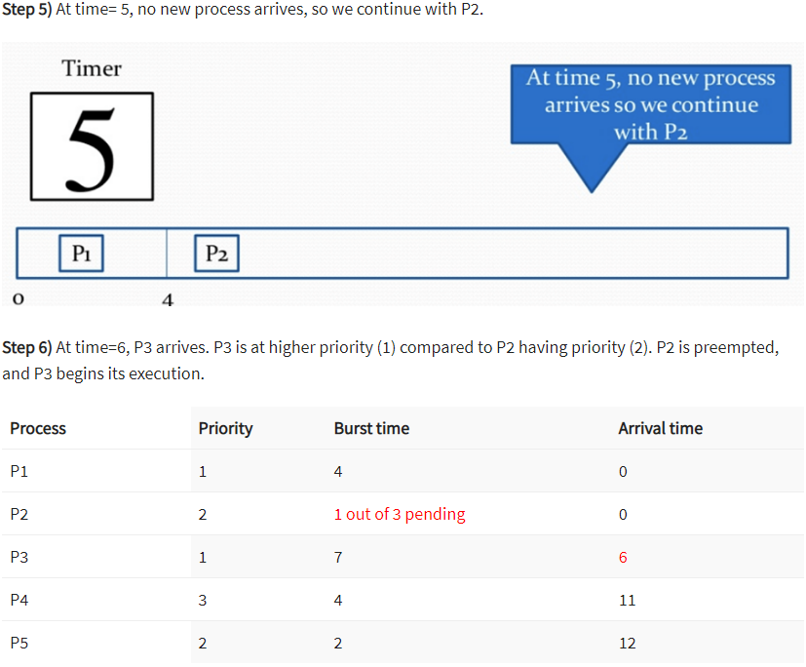

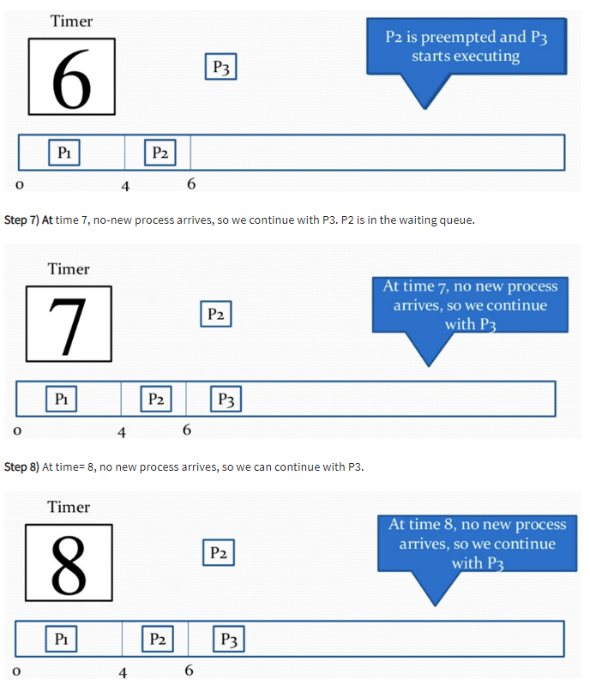

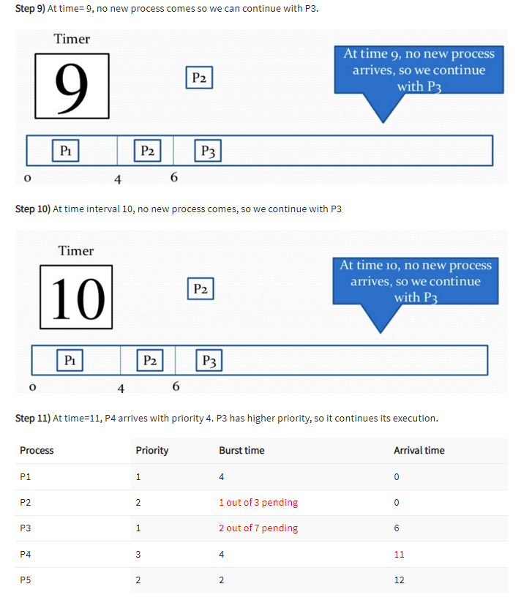

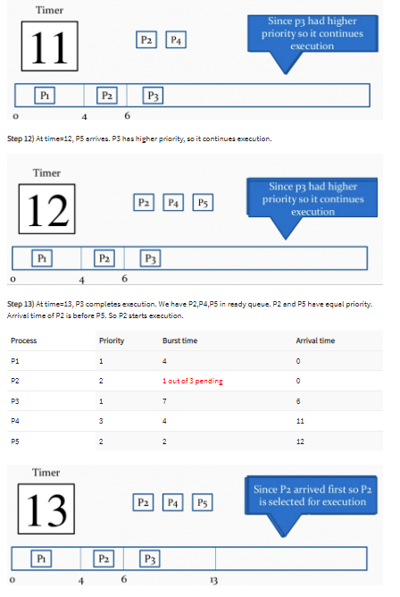

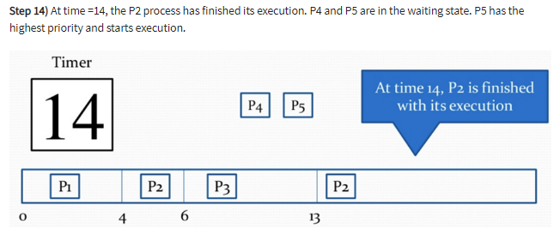

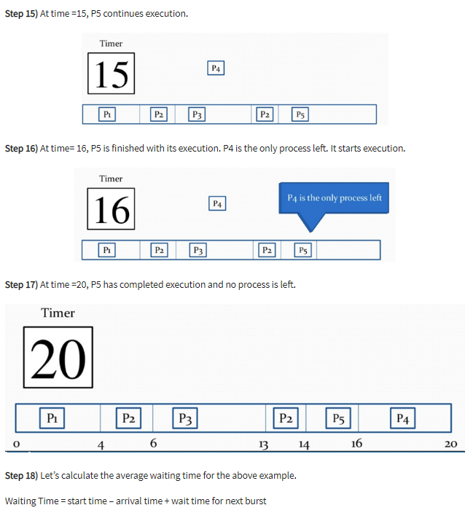

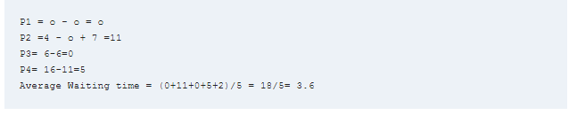

**CODE :**

print("Priority Job SCHEDULLING")

n= int(input("Enter number of processes : "))

d = dict()

for i in range(n):

    key = "P"+str(i+1)

    c = int (input("Enter Priority of the Process : "))

    a = float(input("Enter arrival time of process"+str(i+1)+": "))

    b = float(input("Enter burst/Executing time of process"+str(i+1)+": "))

    l = []

    l.append(a)

    l.append(b)

    l.append(c)

    d[key] = l

 #sorting in terms of Priority of a process

d = sorted(d.items(), key=lambda item: item[1][2])

ET = []

for i in range(len(d)):

    # first process

    if(i==0):

        ET.append(d[i][1][1])

    # get prevET + newBT

    else:

        ET.append(ET[i-1] + d[i][1][1])

TAT = []

for i in range(len(d)):

    TAT.append(ET[i] - d[i][1][0])

WT = []

for i in range(len(d)):

    WT.append(TAT[i] - d[i][1][1]/1000)

avg_WT = 0

for i in WT:

    avg_WT +=i

avg_WT = (avg_WT/n)

avg_TAT = 0

for i in TAT:

    avg_TAT +=i

avg_TAT = (avg_TAT/n)

print("Process | Priority | Arrival | Execute time | Exit | Turn Around | Wait |")

for i in range(n):

      print("   ",d[i][0]," | "," | ",d[i][1][2]," | ",d[i][1][0]," Sec"," | ",d[i][1][1]," Sec"," | ",ET[i]," Sec"," | ",TAT[i]," Sec"," | ",WT[i]," Sec"," | ")

print("\nAverage Waiting Time: ",avg_WT," sec")

print("\nAverage TurnAround Time: ",avg_TAT," sec")

**Output :**

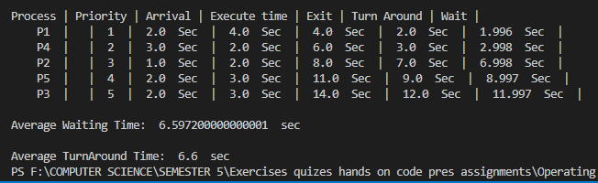

**Task:**

* **Build code for following process using non-preemptive Priority Scheduling.**

### 

